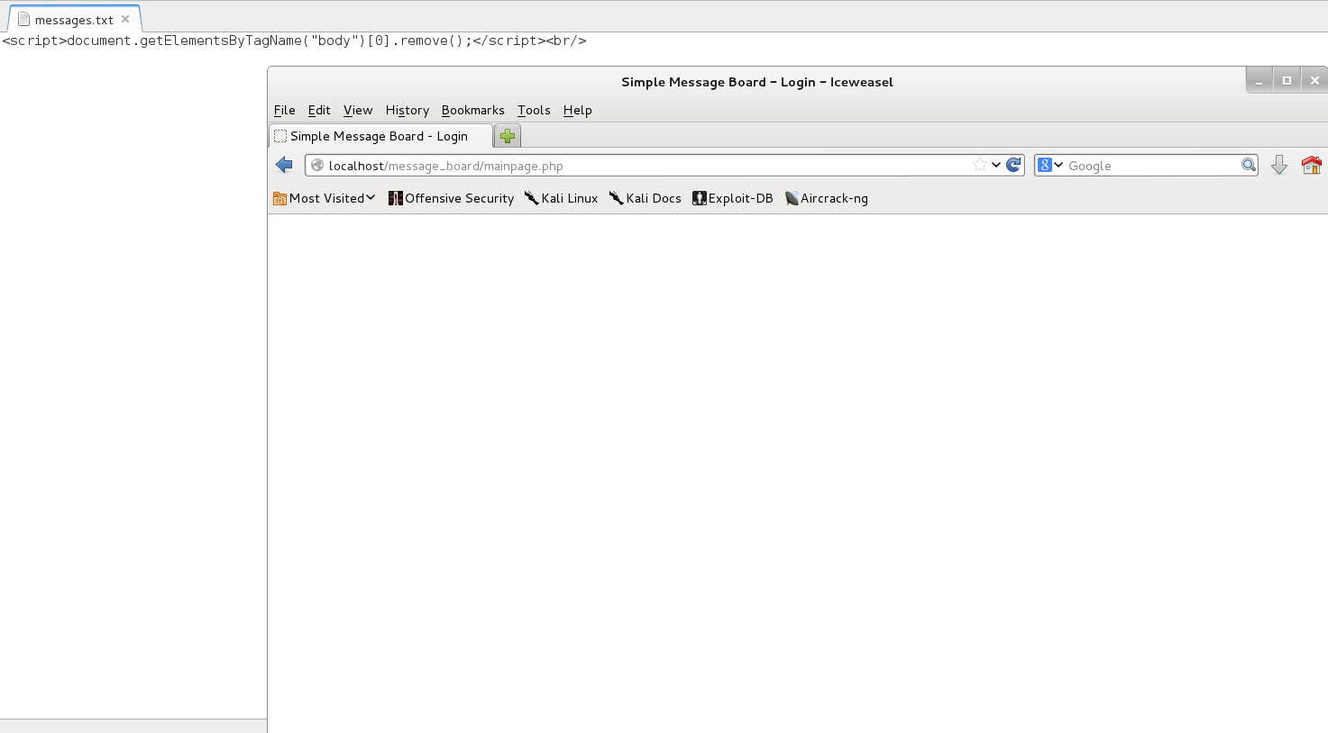

For this attack I inserted the script

<script>document.getElementsByTagName(“body”)[0].remove();</script>

which grabbed every element with the tag “body” and then deletes the first one. This results in the page being cleared and only displaying a blank page. This is a basic persistent attack.

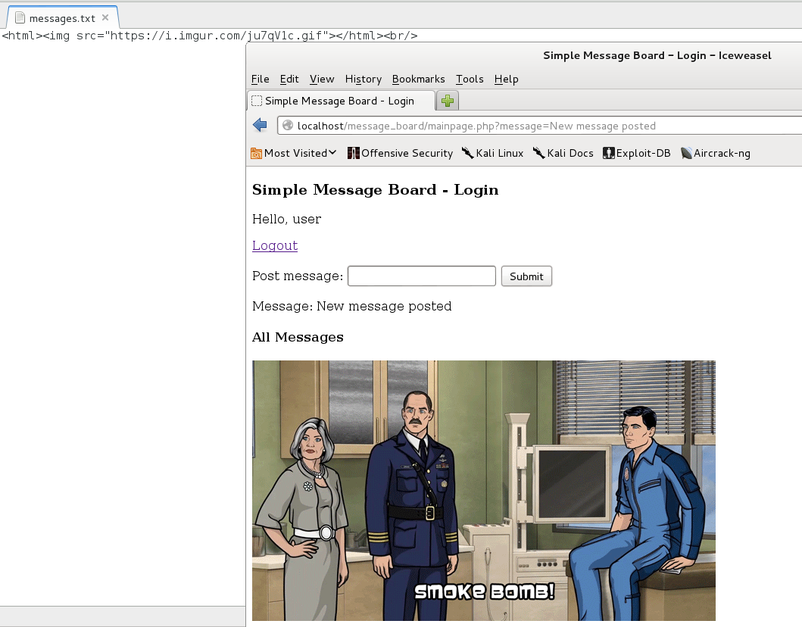

For this injection I inserted

<html><img src=<https://i.imgur.com.ju7qV1c.gif>></html>

Which displays this gif on the message board.

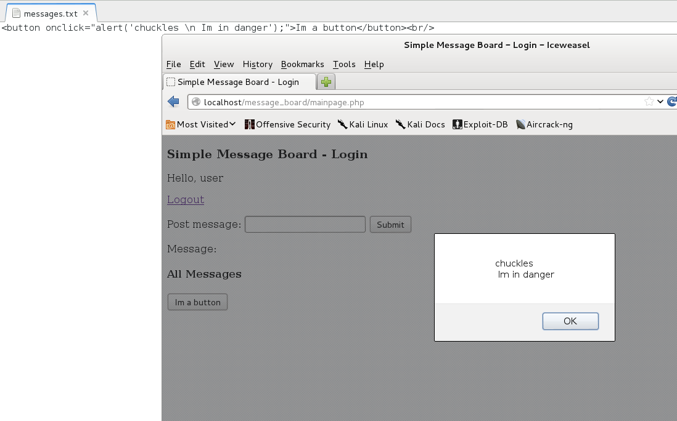

Finally for this attack I injected the script

<button onclick=”alert(‘chuckles \n Im in danger’);”>Im a button(/button>

Which displays a button that will when clicked, will display the alert with the message above.